First:
Pause
Break
- Go to System Information.
  - Either from right clicking on my computer-> properties.
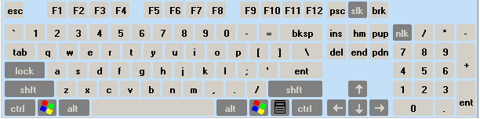
  - Or system from the control panel.
  - Or by pressing WinKey+Pause.
- Choose Advanced Tab.
Win Key
Start Menu
- Click Environment Variables Button.
- In System Variables Click New.
- Enter in variable name: JAVA_HOME.
- Enter in variable value: the path of the folder of the JDK
(e.g. C:\Program Files\j2sdk1.4.1).
- Click OK, then another ok, then a third ok.
- Open a console window (start menu -> Run -> cmd).
- Go to the tomcat folder.
    - C:\Program Files\s1studio\ce\tomcat401
For those who has Sun One Studio.
    - I think tomcat runs automatically with JDeveloper.
    - With JBuilder I think it could be something like SUN ONE.
  - Go to bin.
  - Type “startup”.
  - It must open another window named Catalina.
  - You can open the startup.bat immediately from windows Explorer, but it must also opens CATALINA’s windows, or the tomcat will not run.

  - LEAVE THE CATALINA WINDOW OPENED, IF CLOSED THEN THE TOMCAT WILL BE CLOSED.

Trouble Shooting
- If it said “You must set JAVA_HOME to point at your Java Development Kit installation”.
Then you java_HOME variable is wrong, be sure it’s the JDK folder (where we have javac, java & appletviewer in the bin of that folder), but don’t write the bin in the variable. Just c:\ j2sdk1.4.1, or whatever was the path.

- If the port is reserved or the apache can’t access the 8080 port, open the file in the tomcat401 folder -> conf -> server.xml. Search for 8080, and change it with any other number larger than 1024 (e.g. 1982)
  - Then open the internet explorer with http://localhost:1982/ or the port number you entered.
- An "out of environment space" error with Windows 9x/ME.
  - Right-click on the STARTUP.BAT and SHUTDOWN.BAT files.
  - Click on "Properties" then on the "Memory" tab. For the "Initial environment" field, enter in something like 4096.
  - After you click apply, Windows will create shortcuts in the directory.
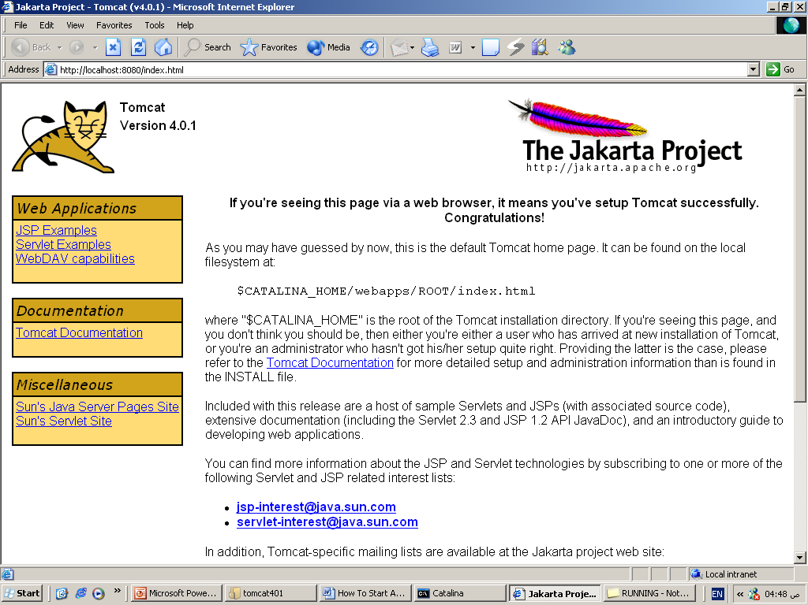
  - Use these new shortcuts instead of the original files to start or stop the tomcat.

If everything goes right:
- Open the Internet Explorer.
- Type the address: http://localhost:8080.
- Apache tomcat page should now be opened.

For more information, see the attached file (Running.txt)
